Using An OM4 Cable On SFP56 Port In 6300 Doesn't Show As OM4

**Labels: ArubaOS-CX Switches**

**Q:**

**Background:**

An SFP28(25Gig) transceiver(**Aruba 25G SFP28 LC SR 100m MMF Transceiver-JL484A)** is used on an SFP56 capable port #1/0/25

on a 6300 switch(**Aruba 6300F 24-port 1GbE and 4-port SFP56 Switch-JL668A**).

Equivalent 48-port switch showing SFP56 capable ports:

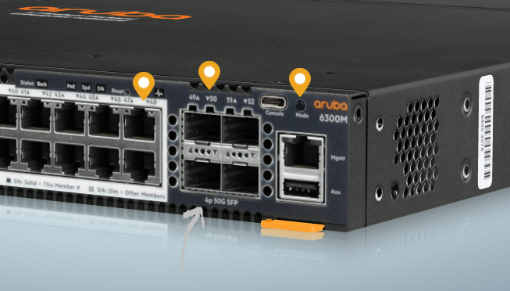

3m OM4 cable used:

[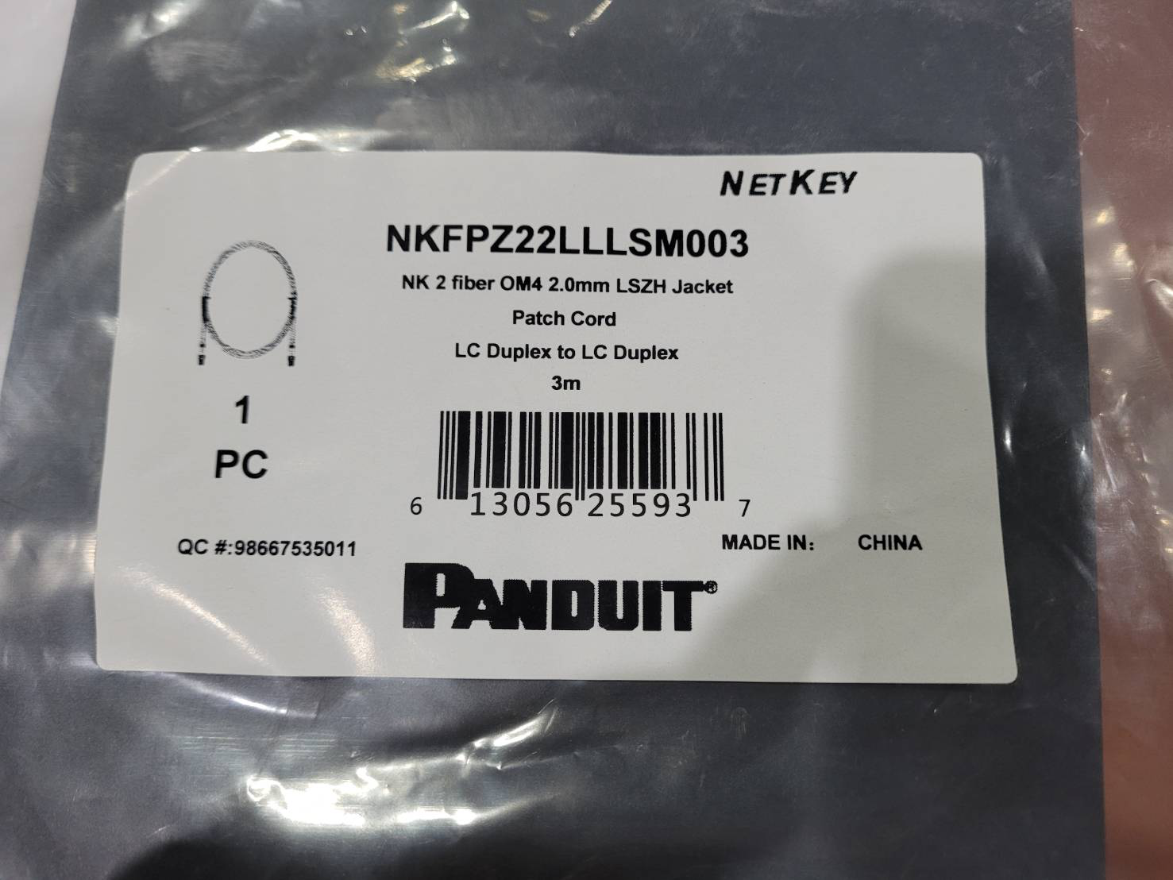](https://akb.arubanetworks.com/media/ckuploads/1110/2021/08/31/3m-om4-cable.png)

**Why output of show interface transceiver shows as OM3, even though we used an OM4 cable ?**

[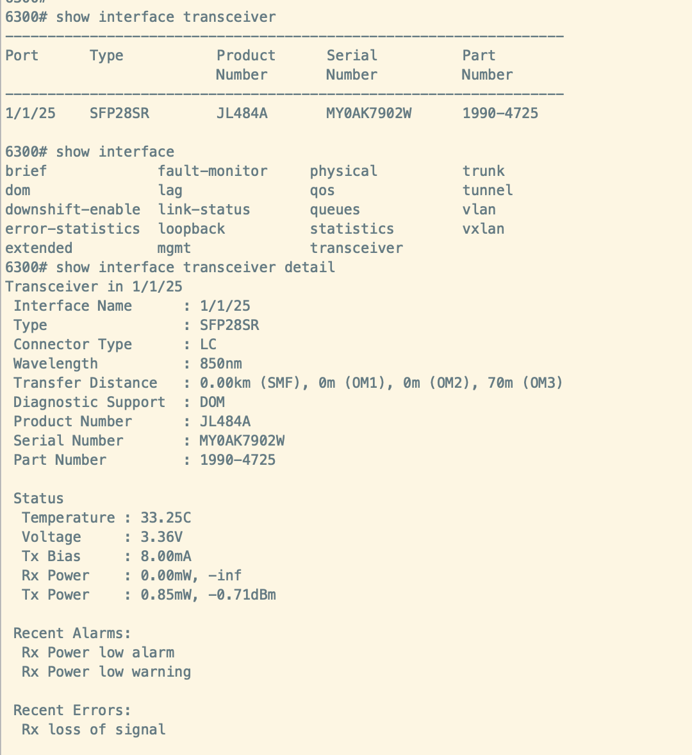](https://akb.arubanetworks.com/media/ckuploads/1110/2021/08/31/show-interface-transceiver-detail.png)

**A:**

No need to worry.

The missing OM4 length from show interface output is a software cosmetic issue.

Moreover,

The output of show interface transceiver detail is the *maximum length supported* with that particular cable.

E.g. OM3 70m means you can use OM3 cable up to 70m.

**Attachments:**

[HPE_a00028947en_us_ArubaOS-Switch and ArubaOS-CX Transceiver Guide (Edition 10).pdf](https://akb.arubanetworks.com/private/articles/612e4b60853cb53c7cdd4f4f/attachments/HPE_a00028947en_us_ArubaOS-Switch and ArubaOS-CX Transceiver Guide (Edition 10).pdf/)

Tags: ArubaOS-CX Switches, arubaos-cx 10.07.xxxx, #6300, sfp28, om4, om3, #sfp56